EX.NO.2.2-CREATE A 3D
SOLID MODEL
FROM ISOMETRIC DRAWING.

AIM
To sketch the given drawing with dimensions using a fusion 360 tool.

REQUIREMENTS

● Computer or laptop
● Autodesk fusion
● Mouse and keyboard
● Windows 10

PROCEDURE
➡➡Open Autodesk Fusion 360 and click Create Sketch.
➡Draw the base plate with an overall length of 68 mm.
➡Draw the rounded ends with an outer radius of R18 mm.
➡Draw the two holes in the base plate with a diameter of Ø18 mm.
➡Mark the hole position using the 12 mm dimension shown in the drawing.
➡Draw the upright support plate according to the given shape.
➡Draw the connecting support and apply the dimensions 32 mm and 40 mm.
➡Draw the upper cylindrical portion with an outer diameter of Ø30 mm and an inner diameter of Ø20 mm.
➡Apply the 10 mm and 8 mm dimensions at the indicated locations.
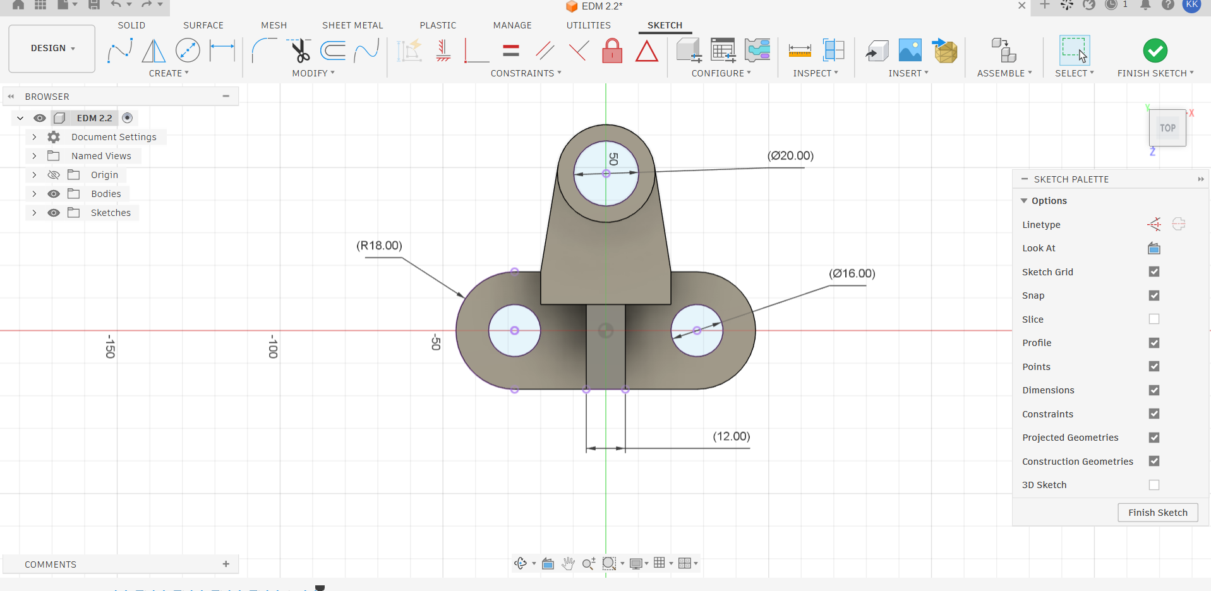
➡Use the Extrude tool to form the 3D model.
➡Check the dimensions and save the completed model.
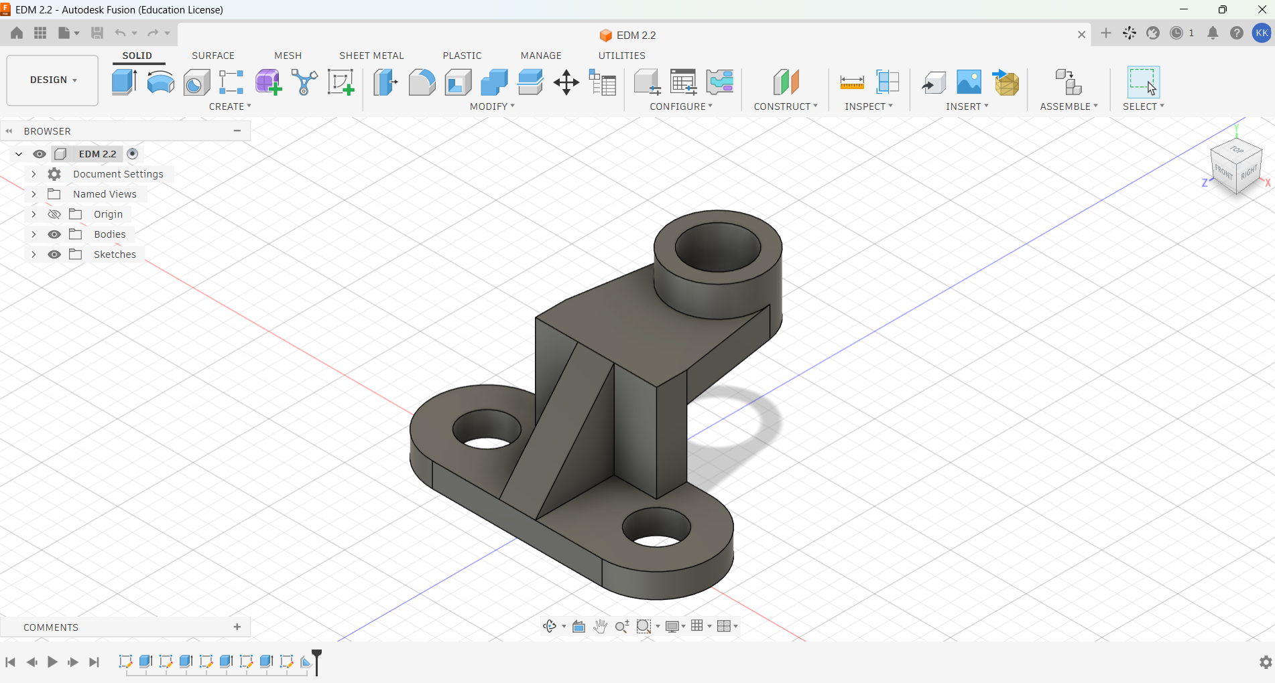

OUTPUT
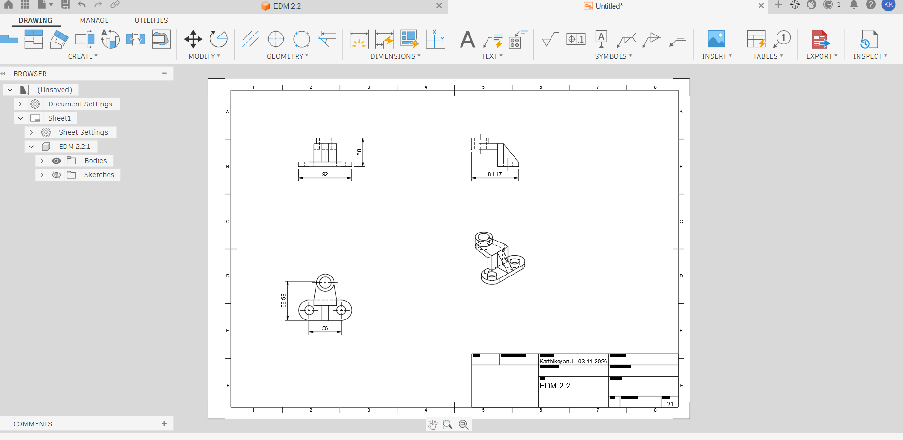

RESULT
Thus, the given sketch is drawn and drafted using fusion 360 tool.

